1. **What is Terraform?**

Terraform is an infrastructure as a code tool that lets you build, change, and version cloud and on-prem resources safely and efficiently. It’s also Open source.

1. How can Terraform be installed on Windows?

To download the Windows application, please visit this web page.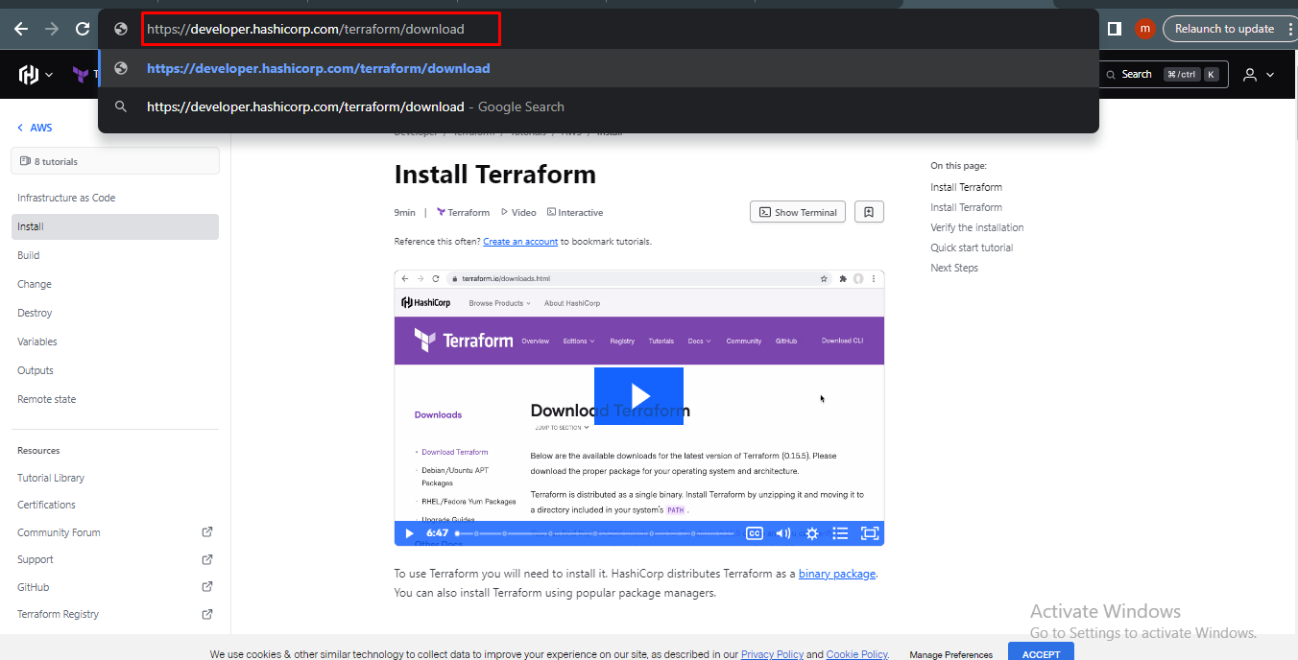

This is a version of the Terraform Application.

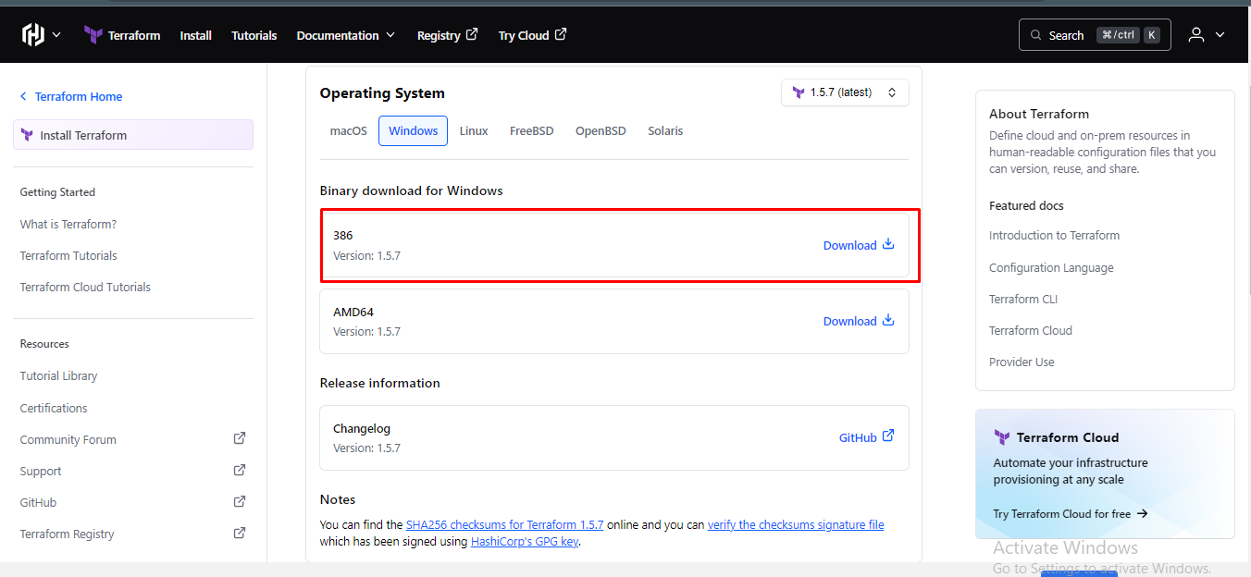

Once you have installed the program, you need to unzip the file.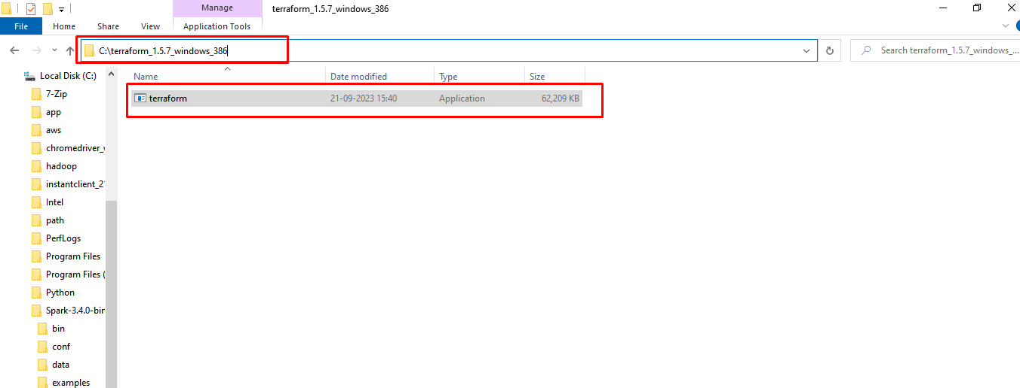

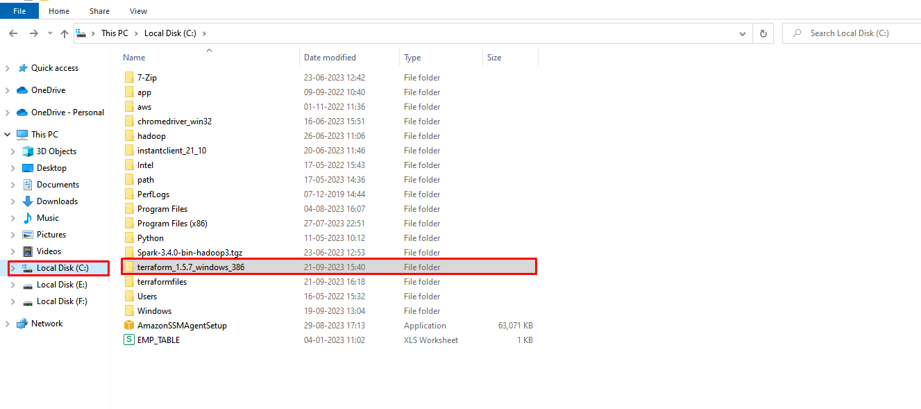

1. what is the environment variable?

An environment variable is a variable outside of a program or script that stores configuration information, settings, or other data that can be used by one or more software applications. Environment variables are part of the operating system's environment and can be accessed by programs running on the computer.

Goto Settings and click on Advanced system Settings Select Environment Variables

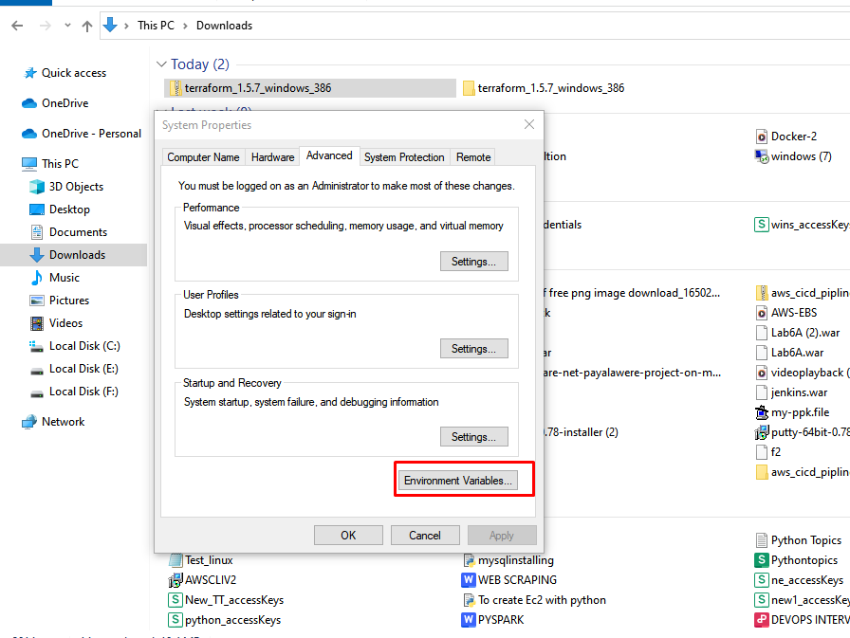

Go to System Variables and click on "Path". Then click on "Edit" and provide the file link.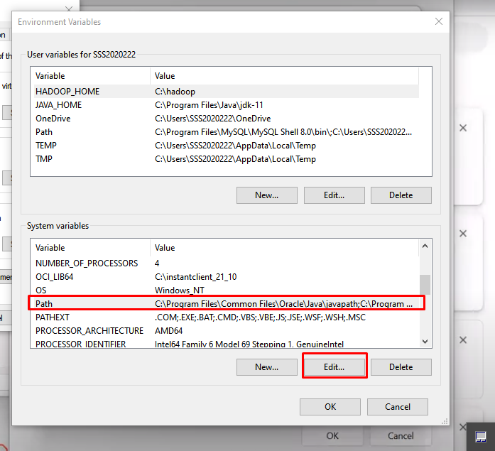

After the Edit click on new and past the Terraform file path

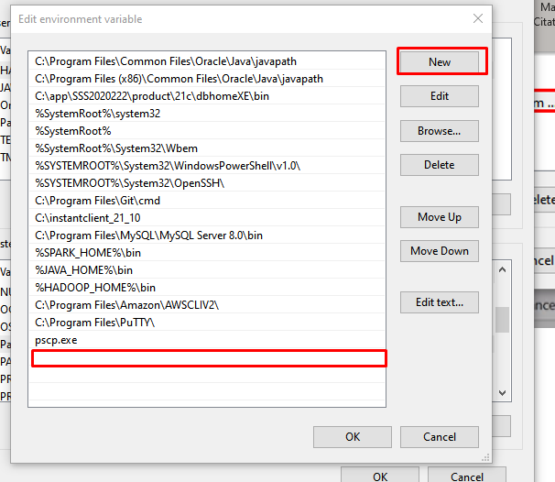

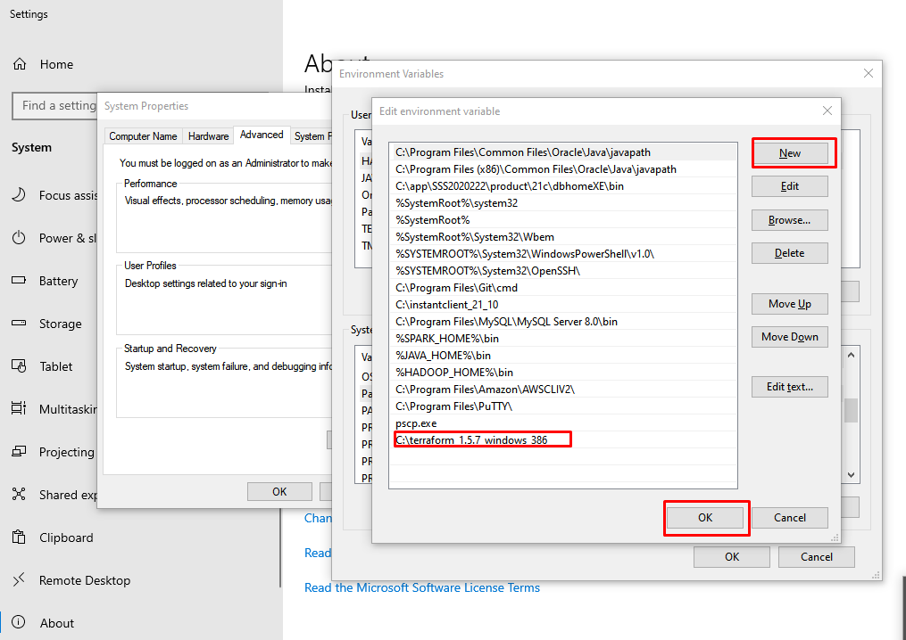

Now go to Git Bash or Command Prompt and install Git on a Windows server. Then, run the command "terraform --version".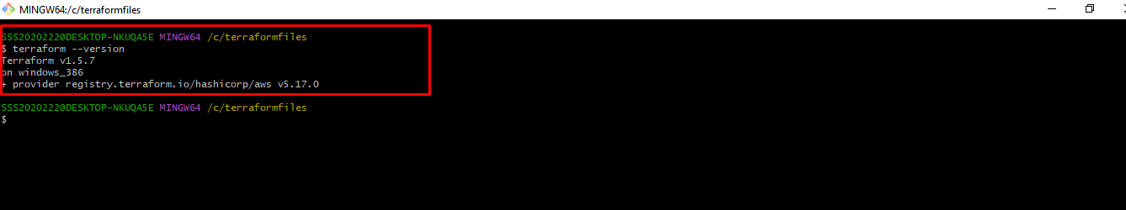

To make the initial dependency selections that will initialize the dependency lock file, run; Terraform INIT, **Initialize Terraform:** Before you can use Terraform apply, you need to initialize your Terraform working directory by running: 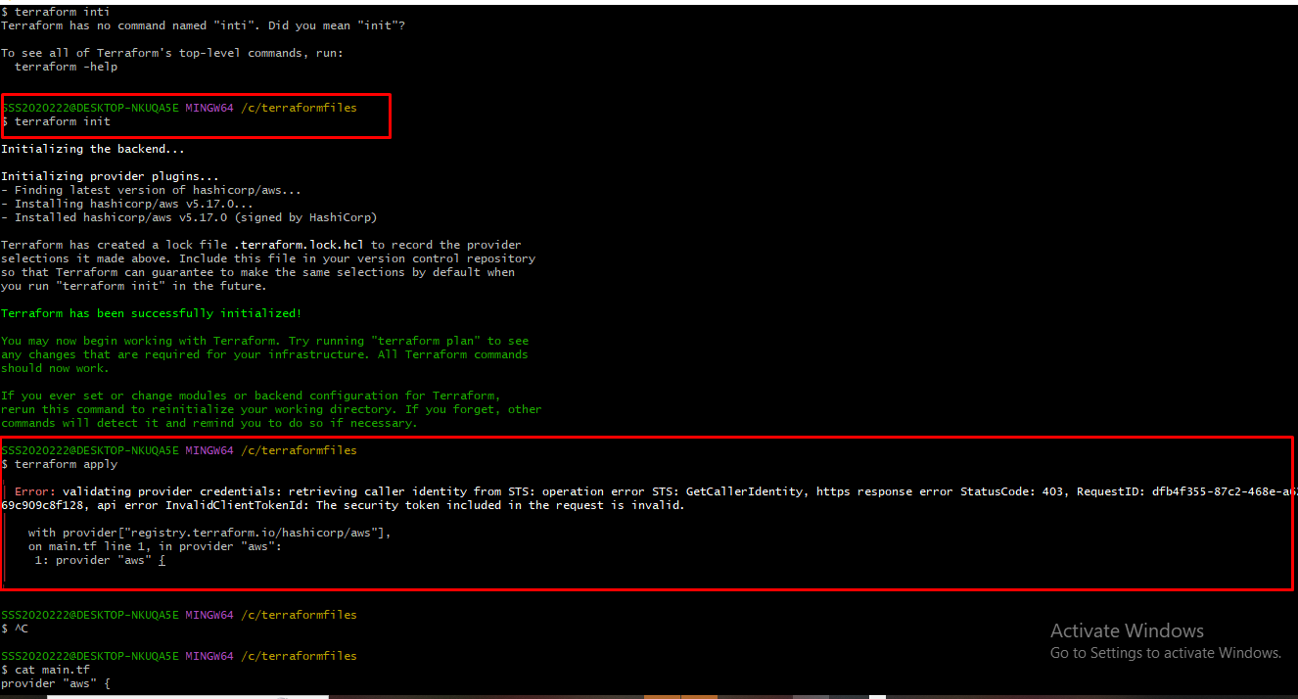

**Apply Changes:** When you're satisfied with the planned changes and are ready to apply them to your infrastructure, you can use **Terraform apply**:

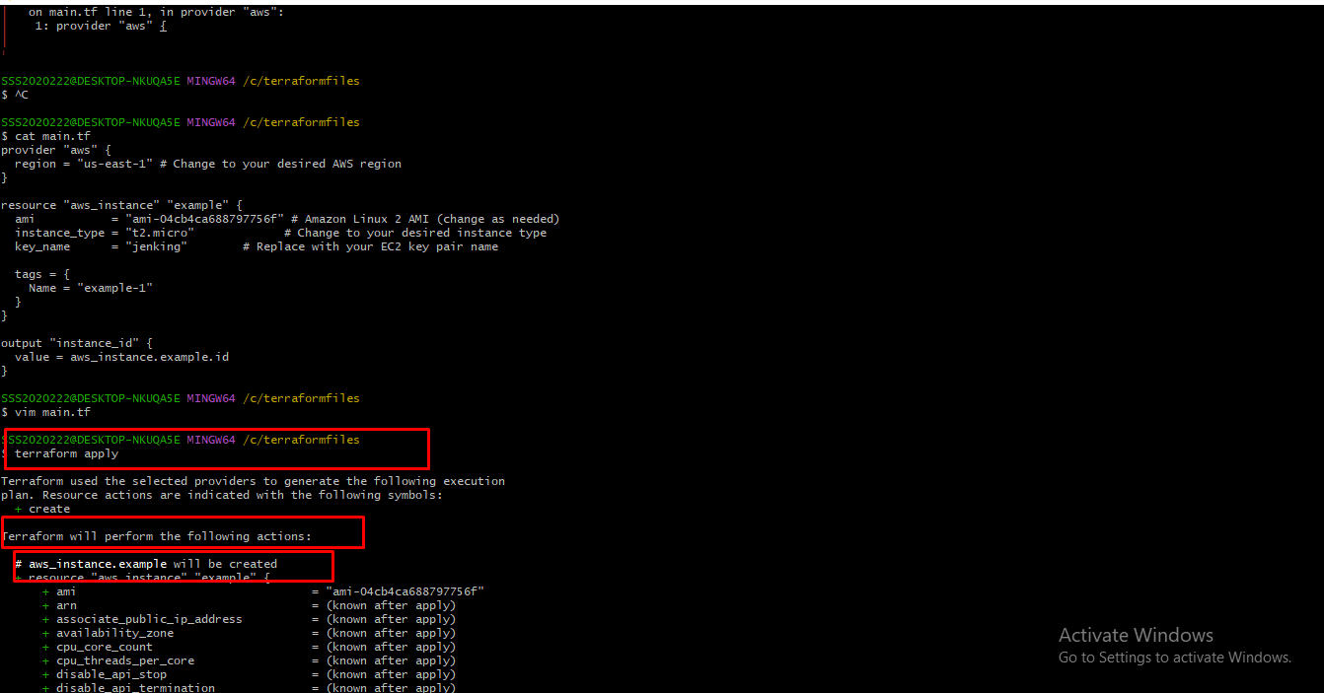

After initialization, this program will prompt the user to enter a value. If installing is safe, type "yes" or "no".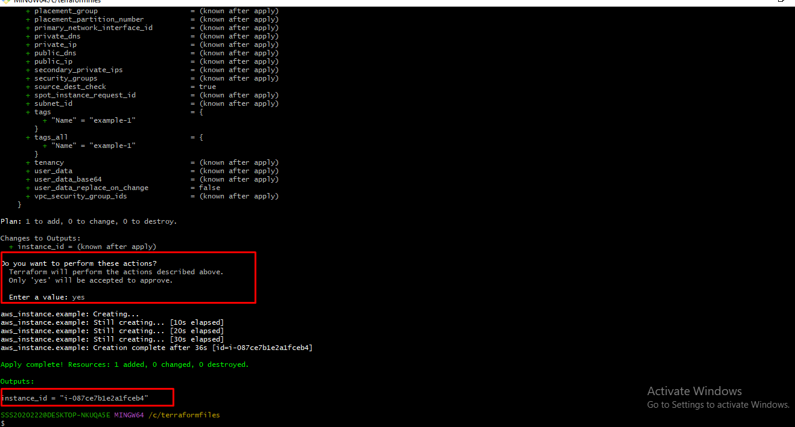

This Terraform script. tf = format 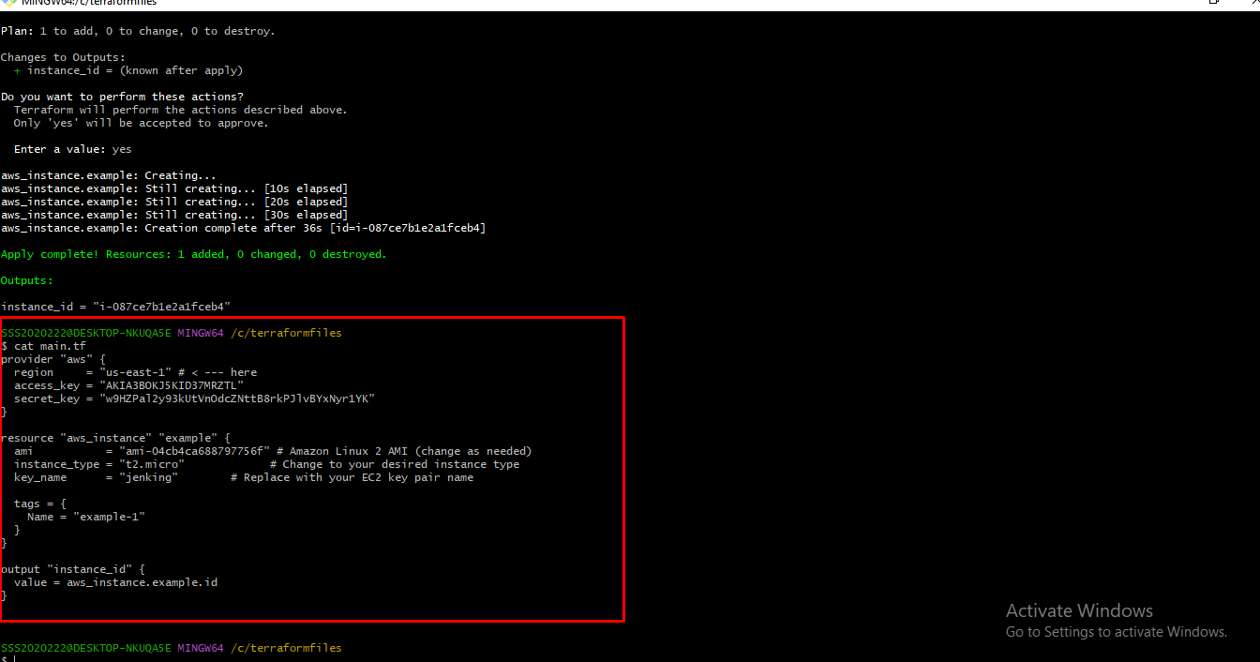

We used the command "Mkdir - Terraformfiles" to create the Windows folder.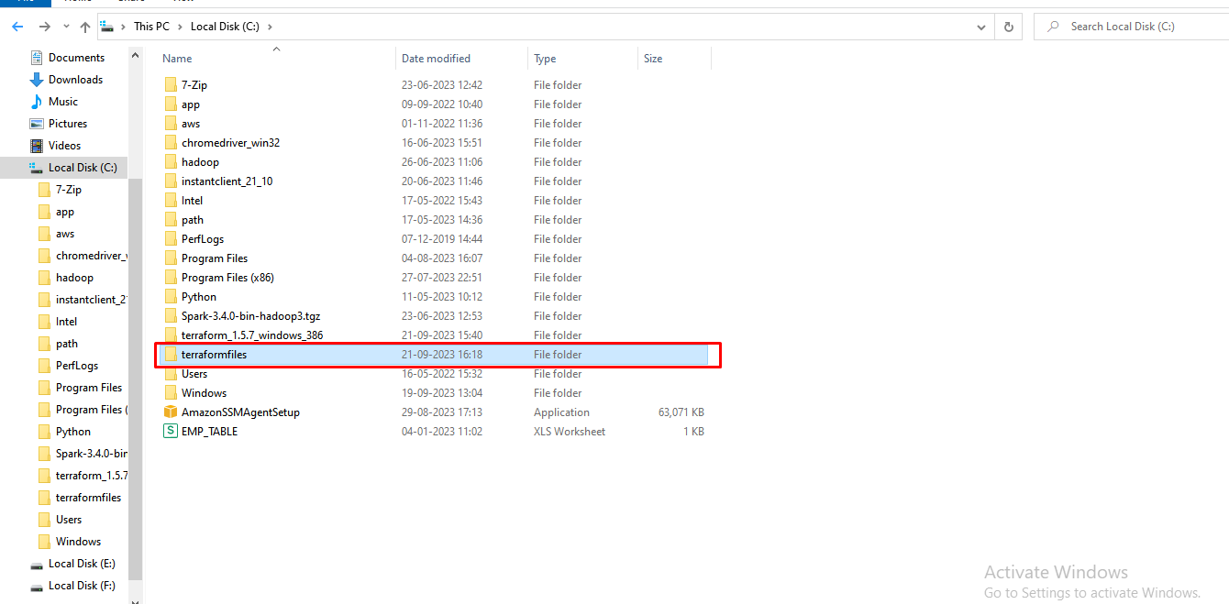

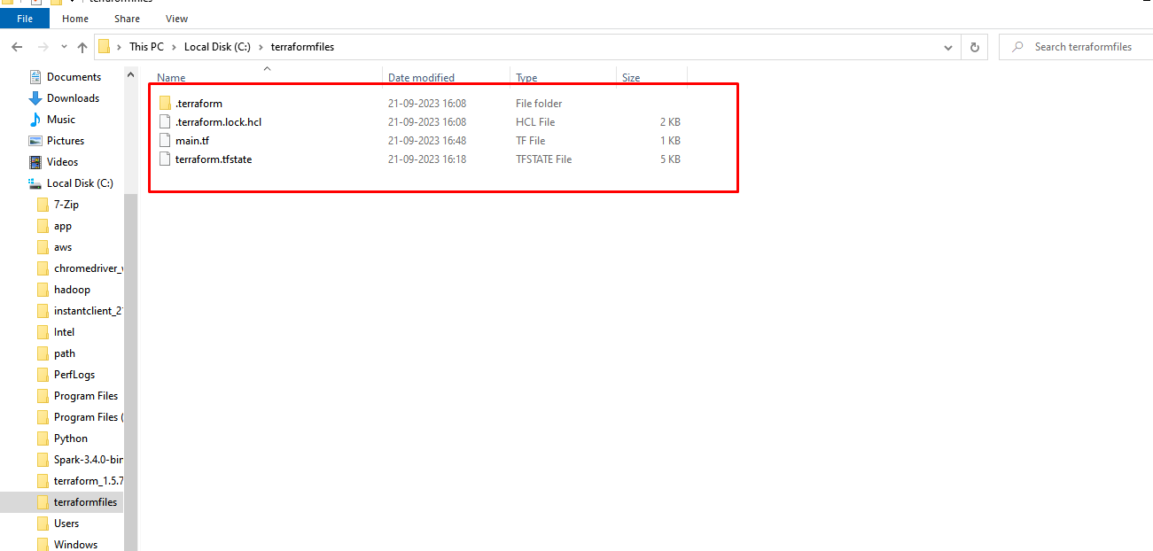This all infrastructure

The instance has been successfully created.